The World Academy of Research in Science and Engineering
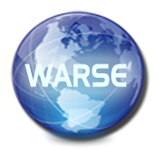
www.warse.org
MEMBERSHIP FORM

Eminent Academicians, Industrialists and Researchers from all fields are invited to join as join as Advisory Board Member/ Program Committee Member of a Conference/Editorial Board Member of a Journal free-of-charge.
If you are interested to join as Advisory Board Member/ Program Committee Member of a Conference/Editorial Board Member of a Journal free-of-charge, please fill the details below (Membership Form) and send the Membership Form along with your CV to editor@warse.org. Your application will be analyzed by WARSE Advisory Committee and your profile meets the requirements of WARSE, we will inform you regarding this.

Full Name
Designation
University/College
Country
Applied for
(Advisory Board Member/ Program Committee Member of a Conference/Editorial Board Member of a Journal)

Note: Mention the corresponding Conference Name or Journal Name
Email id
Phone (with Country code)
Research Fields
Institution Address
(Note: A Ph.D holder from an accredited Educational Institution can apply for the above)
As a member of WARSE
- You will be invited to be the reviewer of the relevant WARSE conference
- You can discount for publishing papers in WARSE journals

